Individual Project Diary

Contributor: Shereece A.A. Victor

ID #: 40105094

Project Title: Codenames Game

Project Group: PJ-b

Course: COMP 354 – Intro to Software Engineering

School: Concordia University Montreal

Start Date: Wednesday 16th January 2019

Expected Completion Date: Date: Sunday 7th April 2019

**Introduce your project in the project diary. Describe what the project is, why you are completing it and when you expect to have it completed.**

According to my understanding thus far, Codenames Game, is a spy themed card game, designed for play with four or more persons. It involves, two Spymasters, and Operatives. The players are divided into two teams, a red team and a blue team.

The game is played with a mixture of red and blue cards placed faced down on the table in a 5x5 grid. The contents and placement of each card are only known to each spymaster. The cards each contain a word which is visible to all, and either a red or blue spy, uncolored civilian or the assassin.

Throughout the game each team’s spymaster is tasked with provided clues that indicated how many and the location of their color spies on the board. The first team to figure out the location of all their spies wins. If either team reveals the assassin, they lose and the game ends.

The goal of my team’s project to recreate this game in a computer program in three iterations. The first, gives the user minimum input, and the last allows the a user to participate in the game.

Create a schedule of milestones. This is a list of goals you wish to complete and a time frame for each during the project. Planning your schedule gives you goals to hit instead of just having one final completion date.

**Record information about who is working on the project and what everyone’s duties are during the project. This will define their roles and provide clarity for accountability to everyone participating or reviewing your project diary.**

PJ-b Initial Team Members:

BT - Benjamin Thérien   
DT - Daniel Thibault-Shea  
MZ - Mordechai Zirkind   
RZ - Rezza Zairan   
SV - Shereece Victor  
SZ - Steven Zanga

PJ-b Final Members

AP - Ashesh Patel  
BR - Bilal Rana  
CS - Christophe Savard  
DS – Daniel Thibault-Shea  
BT - Benjamin Therien  
SV - Shereece Angell Agatha Victor  
MW - Michael Wilgus  
RZ - Rezza-Zairan Zaharin  
SZ – Steven Zanga  
MZ - Mordechai Zirkind

**Update your progress on a regular basis in your project journal. Determine how often you will provide updates. Include a written update as well as photographs of the completion of the project if you are working on a physical object.**

Wednesday, 16th January, 2019 | 8:15pm – 9:15pm (approx.) | H Building 7th Floor Common Area

Attended by:

BT - Benjamin Thérien

DT - Daniel Thibault-Shea

MZ - Mordechai Zirkind

RZ - Rezza Zairan

SV - Shereece Victor

SZ - Steven Zanga

Team Meeting 1a

* To begin the meeting, we played the card game, Codenames, to familiarize ourselves with the gameplay and rules.
* After the game I understood finally understood the game.
* I presented by idea of using a 5x5 matrix data structure to represent the game board and assigning each of the matrix’s contents to a one-dimensional array for ease of use. Then using a random function to assign the cards to each space.
* MZ initiated the discussion of how we would implement the game and spoke about logical game design using objects.
* SZ and BT retaught the MVC model, because we were still unclear of it.
* We all participated in a discussion about where the logic of the system would be contained, if it would be in the controller or the model.
* We discovered that our group had been expanded and thus we went to the lab to meet them.

Wednesday, 16th January 2019 | 9:30 pm – 10:40pm (approx.) | H 903 Lab

Attendees: AP – Ashesh Patel*  
SP – Saad Patel*  
BT - Benjamin Thérien  
CS – Christophe Savard*   
DT - Daniel Thibault-Shea  
MZ - Mordechai Zirkind   
MW – Micheal Wilgus*   
MZ - Mottel Zirkind  
RZ - Rezza Zairan   
SV - Shereece Victor   
SZ - Steven Zanga

Team Meeting 1b

* We met the new members of our team (labelled with an ‘*’).
* We met the tutor, he gave us guidance on what is expected.
* The different roles were discussed: Coders, Documenters, Organizers, Quality Assurance.
* We chose our roles for this iteration, I am a documenter, because I didn’t do any Java programming prior to this course and needed time to learn and adapt.
* It was declared that everyone will be involved in coding and testing.
* We discussed the skills needed: knowledge of Java, Unit Testing, GitHub etc.
* I think I am the least knowledgeable and experienced in this group.
* The software, websites and accounts we will be using to go the project.
* The MVC model was recapped.
* We discussed the database that may be needed, and maybe storing words, their hints and even pre-generated game boards in them.
* We discussed, what game statistics would be displayed, how intelligent the computer players should be, the game cycle, and tasks to do by next week.

Wednesday, 23rd January 2019 | 9:30 pm – 10:40pm (approx.) | Capstone Project oom

Attendees:

Via Discord:   
BR - Bilal Rana  
CS – Christophe Savard   
SZ - Steven Zanga

Present:   
AP – Ashesh Patel  
BT - Benjamin Thérien  
DT - Daniel Thibault-Shea  
MW – Micheal Wilgus  
MZ - Mordechai Zirkind   
RZ - Rezza Zairan   
SV - Shereece Victor

Meeting 2

* We discussed what we each want out of the course, I want to not be too stressed.
* We recapped what we each did that week.
* I had written and posted the meeting minutes and downloaded a Latex editor.
* Documenters were assigned the task or drawing UML diagrams.
* We realised a flaw in our work as a team, we were trying to write code before establishing the scope and requirements of the project.
* Learned about the code written so far, how they fit into the MVC model and got an idea of what objects will be used and how they come together to form the game
* Finally, I suggested that team mates share their progress with the group to improve synergy.

Tuesday, 29rd January 2019 | 3:00 pm – 4:05 pm | -

Personal work

* Reviewed code posted on GitHub
* Downloaded Latex Document template and making edits to see how it works

Wednesday, 30th January 2019 | 3:00 pm – 6:00 pm | LB Sandbox

Attendees:   
  
MZ - Mordechai Zirkind   
RZ - Rezza Zairan   
SV - Shereece Victor

* Discussed the gameplay with MZ
* Discussed the format of the use cases and their format with RZ
* Researched use cases and examples of use cases
* Started writing main use cases in Word Document

Wednesday, 30th January 2019 |7:00 pm – 9:25 pm | H Building 6th Floor Common Area

Attendees:   
  
MW – Micheal Wilgus  
MZ - Mordechai Zirkind   
RZ - Rezza Zairan   
SV - Shereece Victor

* Transferred Use Cases to Latex Document
* Spent hours trying to debug syntax errors
* MW found the solution at the end
* Discussed UML and Use Case diagrams
* RZ suggested a good software for drawing UML diagrams

Wednesday, 30th January 2019 |9:30 pm – 10:30 pm | H 903 Lab

Attendees:   
  
AP - Ashesh Patel  
BR - Bilal Rana  
CS - Christophe Savard  
DS – Daniel Thibault-Shea  
BT - Benjamin Therien  
SV - Shereece Angell Agatha Victor  
MW - Michael Wilgus  
RZ - Rezza-Zairan Zaharin  
SZ – Steven Zanga  
MZ - Mordechai Zirkind

Meeting 3

* Discussed Progress with Tutor
* I created a list of tasks to be completed by next week based on the requirements mentioned by the tutor.

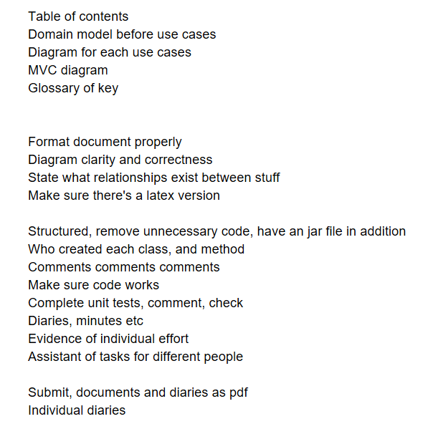

* Clarified again, the work to be done for the first iteration

Summarize the project at the end. Indicate when the project was completed and reflect back on the success or failures along the way. Once again, include a photograph if possible.